

CSE2062

Object Oriented Programming

Project2

Instructure: Şakir Bingöl

|  |  |  |
| --- | --- | --- |
|  | Student ID Number | Name & Surname |
| 1 | 150718031 | Alperen EROĞLU |
| 2 | 150718052 | Ravzanur TOK |
| 3 | 150718056 | Berat Asrın CAFEROĞLU |
| 4 | 150718059 | Ezgi SÜNE |
| 5 | 150718060 | Zeynep DOĞAN |

# fılm & series watching guide application

In this project, it is aimed to make a watching guide for the benefit of film-series watchers. Certain elements that should be in a viewing guide are processed for different users.

In the project, different users were added (and their information was kept) by ***sign up***, and then different film-series options were presented in different categories. In addition, random content (movie-series) suggestions were also made. After ***signing in***, the user can see the contents suitable for his/her taste in the watching guide and access various information about these contents. In addition to the content information, film-series trailers can be accessed on the web. If the user wants to search for a film-series, he/she can go to the content information by using the ***search*** button. If the user wants to get suggestions, he can see random suggestions on the ***homepage*** depending on the category.

Main elements of the project:

* Sign up.
* Sign in.
* Viewing user information (account details).
* Categories.

Watching Guide

* Content information.
* Content search.
* Content suggestion.
* Sign out.

This kind of watching guide has been designed with the thought that it may meet some of the needs of TV film-series lovers.

The working principle of the project will first be shown on the application and then the codes will be examined.

(Since the project has a dynamic structure, a more exemplary version of the application will be realized with video presentation.)

Video link:

<https://drive.google.com/file/d/1xaf8m_lZ0qIzXySKhbSIwao6AGKefDF7/view?usp=sharing>

Opening:

Splash Screen

The name of the watching guide is FILMBOX, and the splash screen is shown like this for a few seconds.

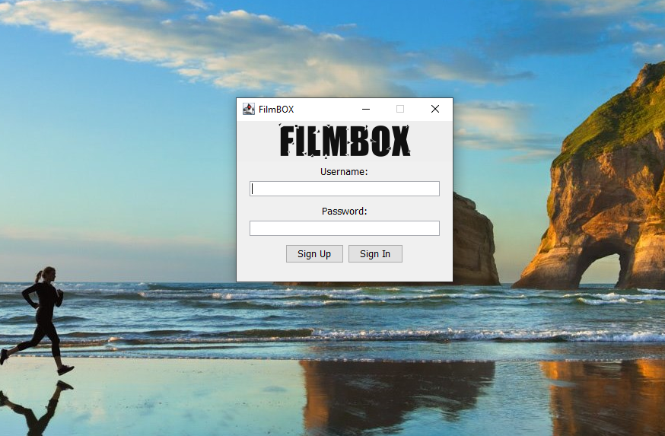

Entrance Screen

On this screen, the user has **sign in** and **sign up** options. Of course, in order to sign in, sign up must be done first.

***SIGN UP and SIGN IN***

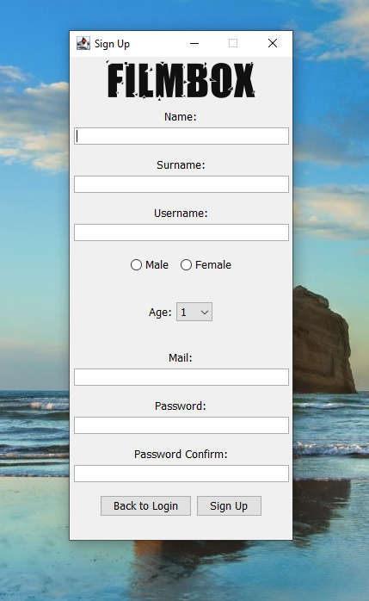

As seen on the screen, name, surname, gender, age, mail, and password are requested for user sign up.

Sign Up Screen

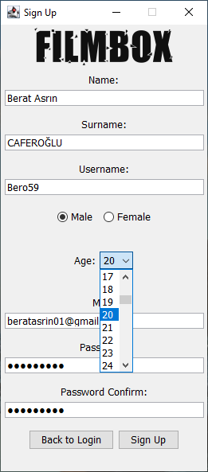

After the information is entered (here is a small detail, the combobox is used to enter the age) by pressing the **Sign-Up** button, the user is registered. If not, the entrance screen is returned with the **Back to Login** button.

After signing up is completed, **Sign In** will be tried. For sign in, username and password will be used.

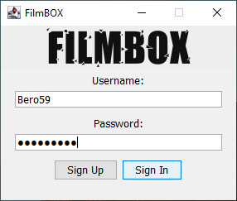

User1 Sign in Using Entrance Screen

User1 Sign Up

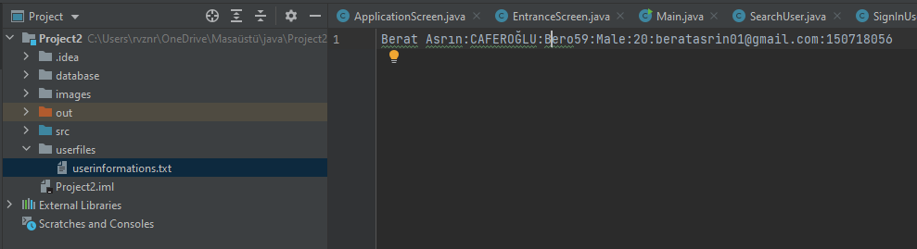

User Information Text File

Users are kept in a file; it is seen that the file is updated as the user is added.

Now let's try a few controls for sign in and sign up.

If wrong information is entered (username is Bero59 not bero59)

If missing or no information is entered

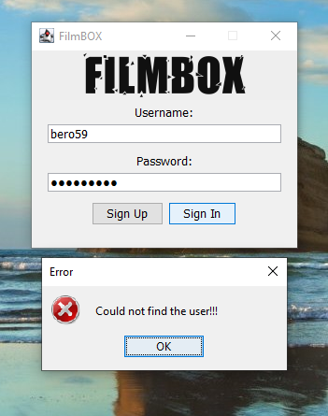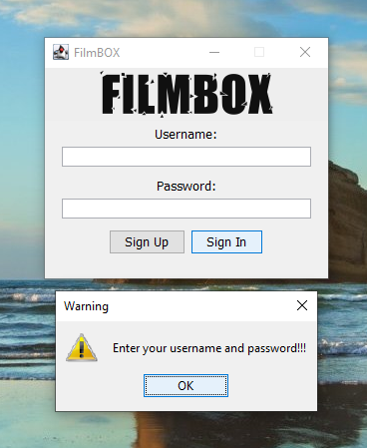

Entrance Screen

It is sufficient not to enter one of the information for the warning message. Likewise, for the Error message, it is sufficient to enter one of the information incorrectly.

If dismatched password is entered

If missing or no information is entered

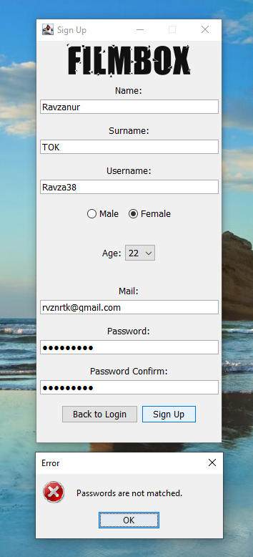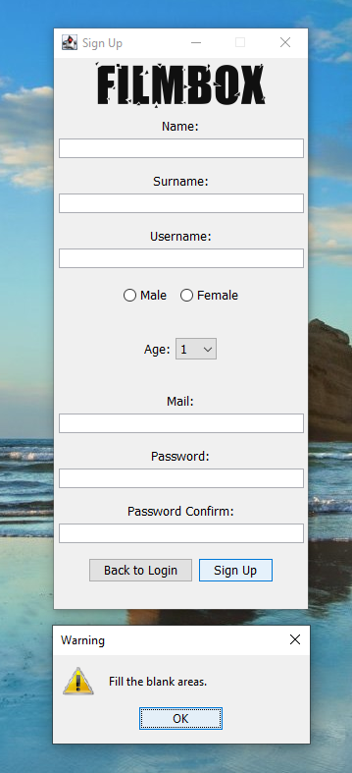

Warnings Using Option-Pane in Sign-Up Screen

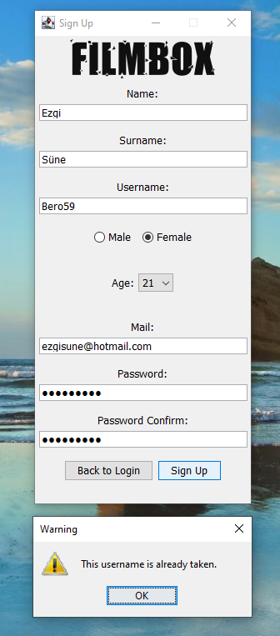

if the previously saved username (Bero59) is re-entered

if sign up window is wanted to be closed

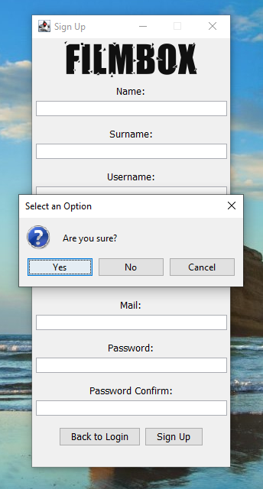

Warnings Using OptionPane in Sign-Up Screen

In order not to overlap the screens, the *entrance screen* was closed when the *sign-up* screen was opened. If “*Yes”* is clicked on the message optionpane, the program is closed, if *No* is clicked, the entrance screen is returned. When *Cancel* is clicked, only the messagebox is closed and the program continues on *sign-up screen*.

As can be seen, different optionpanes such as **warning**, **message** and **error** are used.

The entrance to the application is over, now the watching guide will be examined.

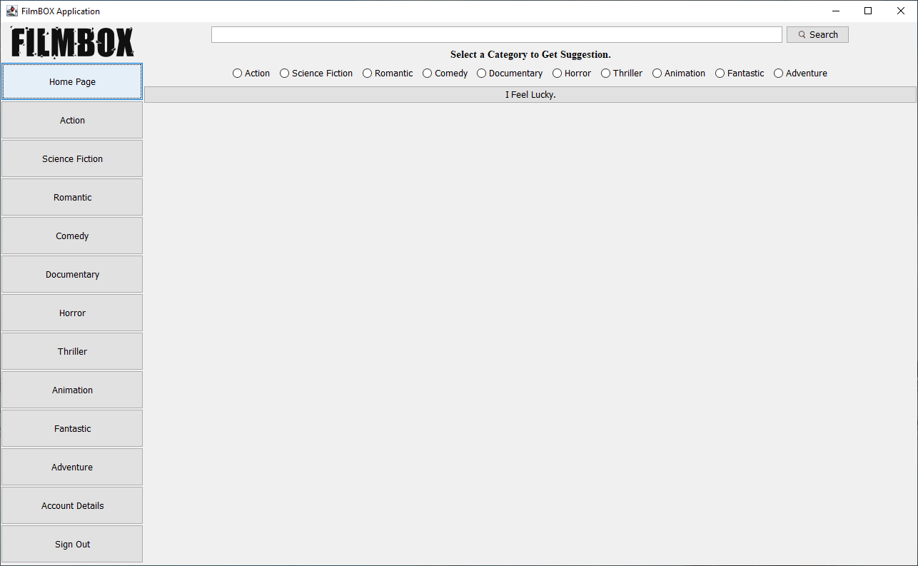***WATCHING GUIDE***

Application Homepage Screen

As seen on the main screen, there are categories on the right. At the top, you can see the **Search**, where we can search for content, and **Select a Category to Get Suggestion** sections where we can get suggestions on the **homepage**.

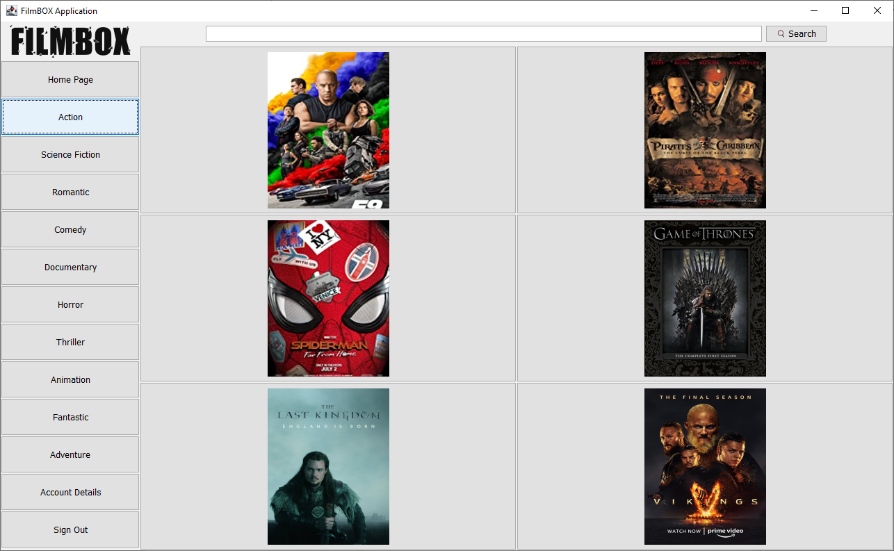**Categories:**

Action Contents

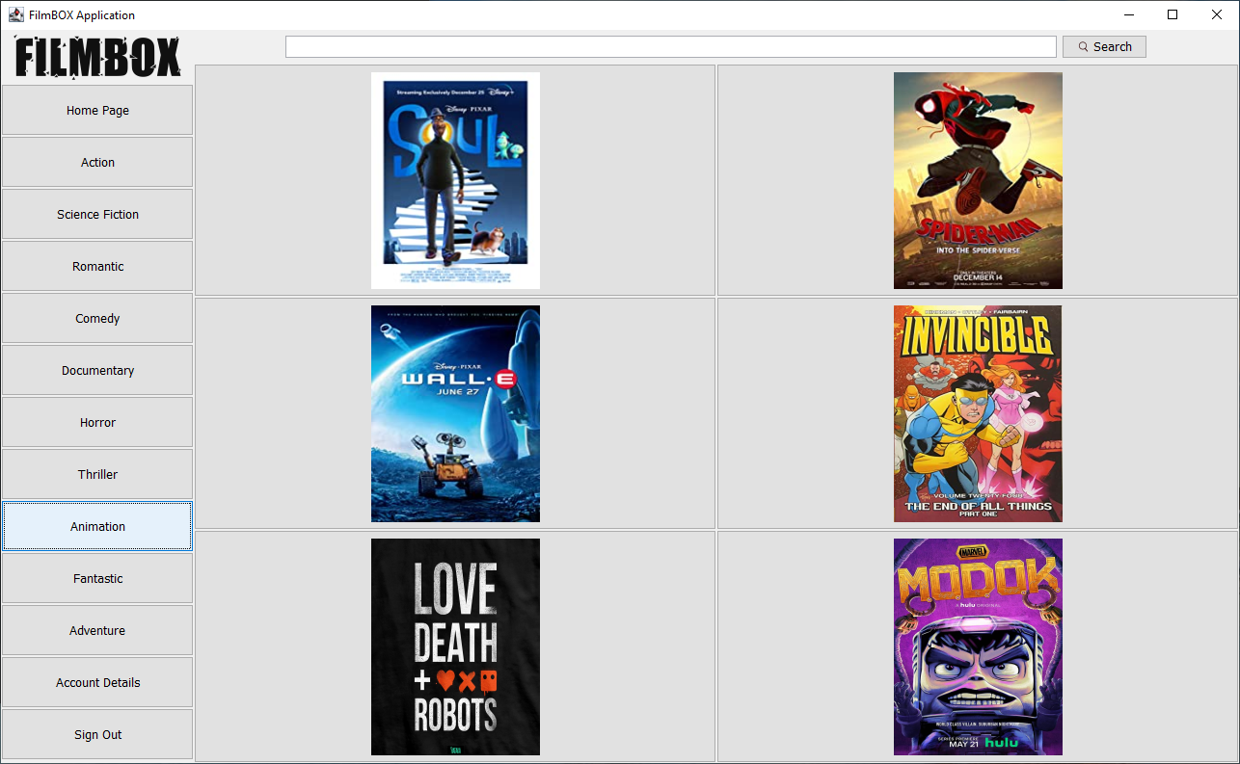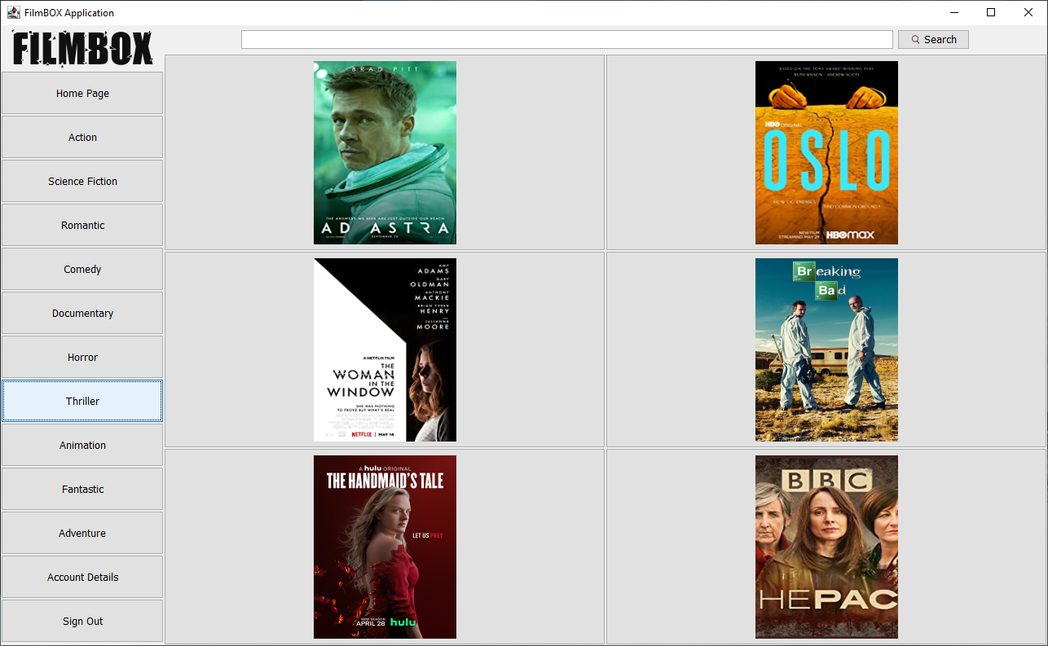

Animation Contents

Thriller Contents

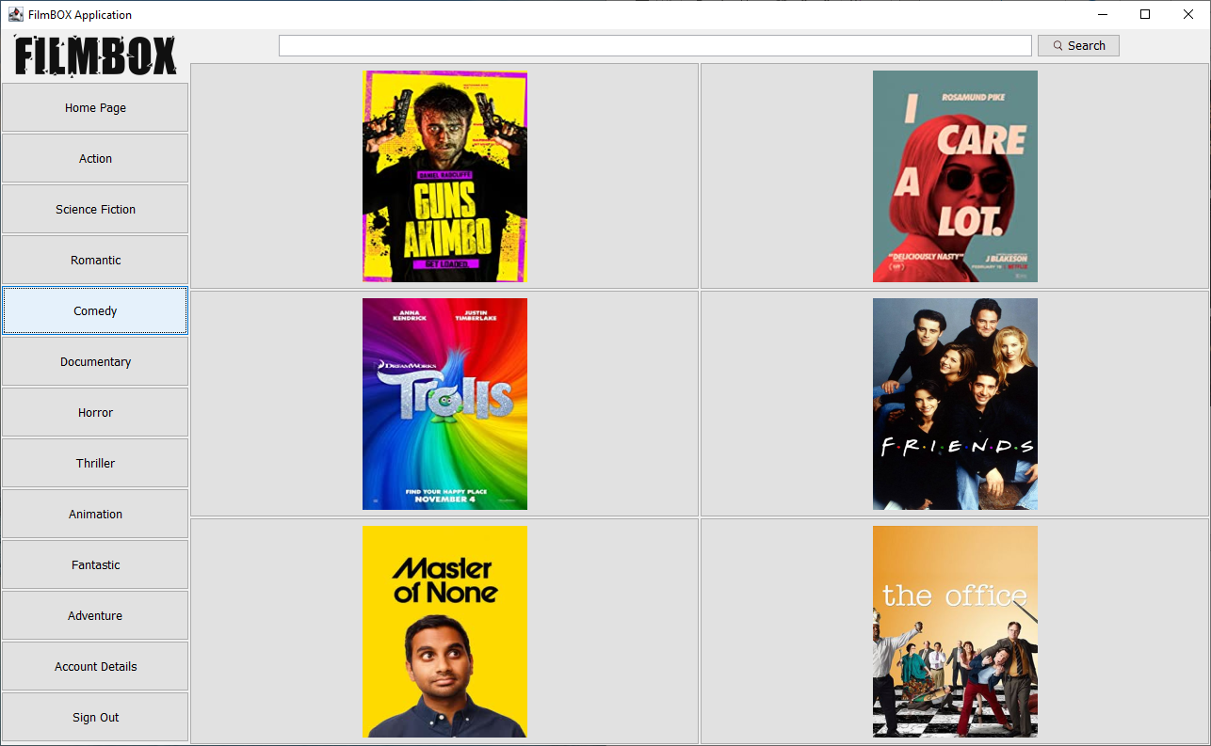

Comedy Contents

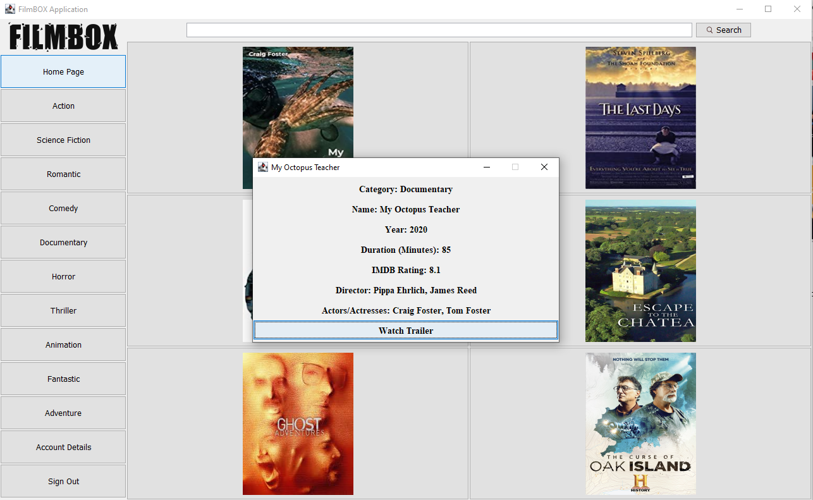6 contents in 10 different categories can be seen in this way. So, can we get information about the content?

Content Information

Category, name, release year (also season information for series), duration, IMDB score, director/s, actors/actresses information can be accessed by clicking the picture of the content. You can also watch the trailer from the web link with the **Watch Trailer** button.

Some examples for **content information**:

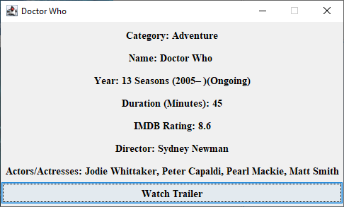

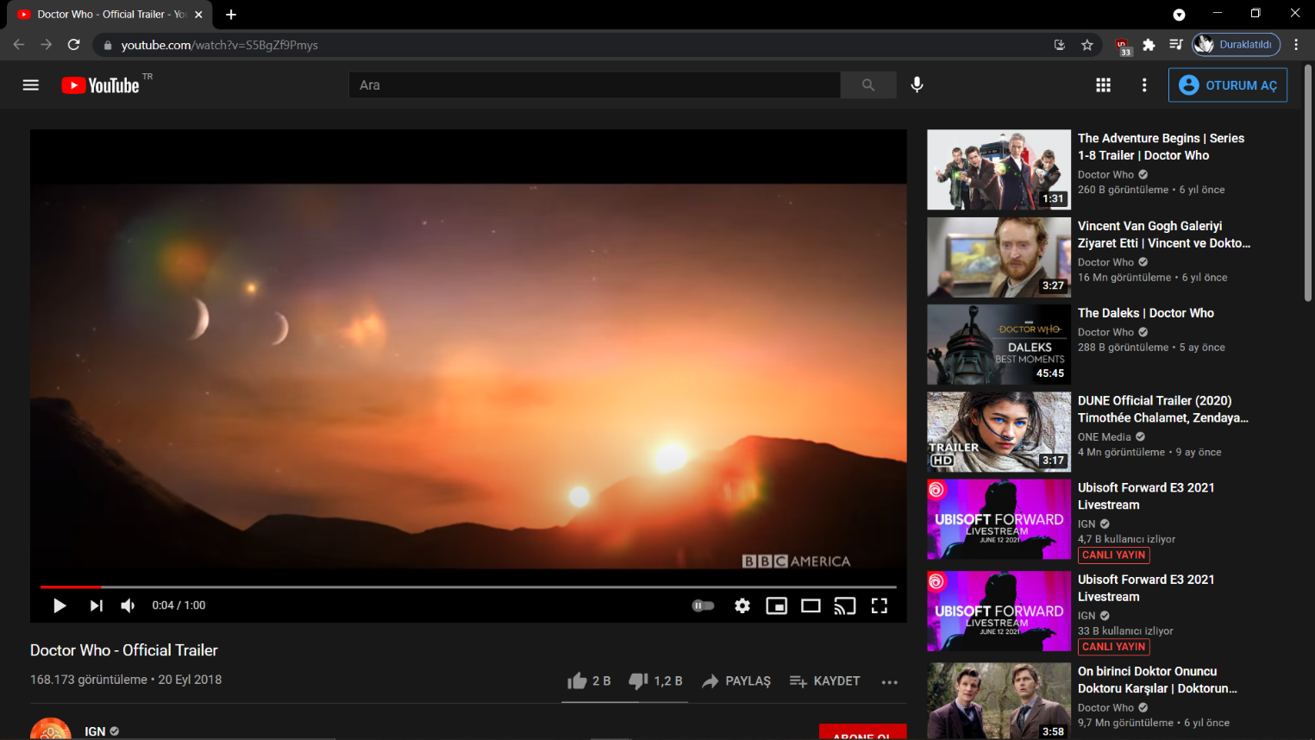

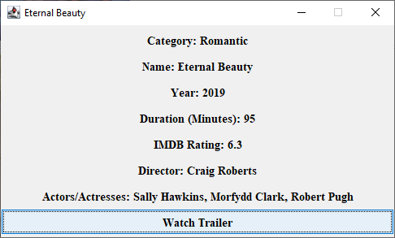

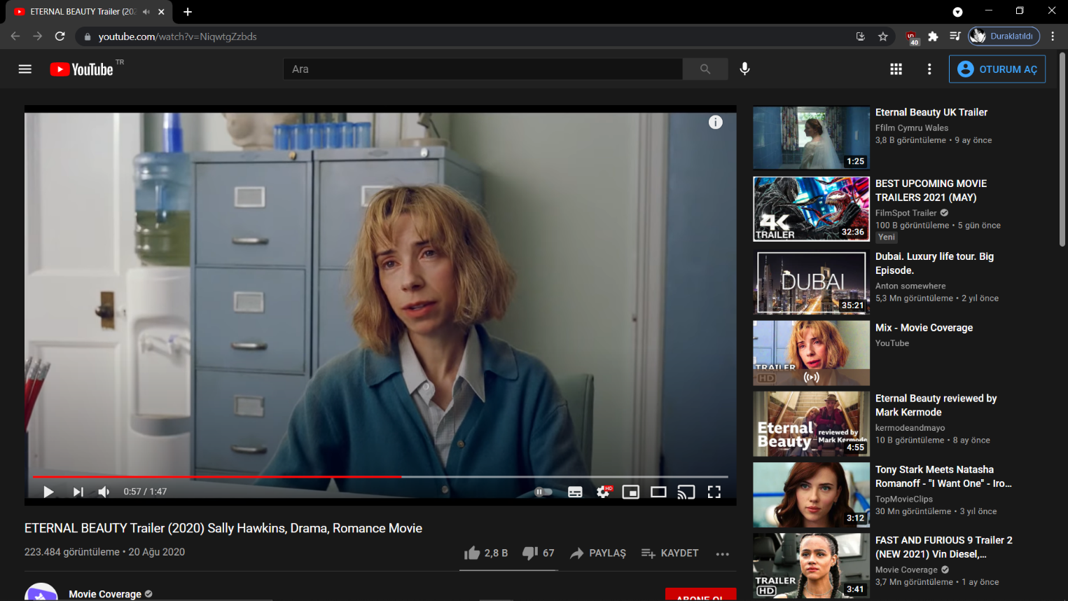

If **Account Details** is clicked, the user can access the information.

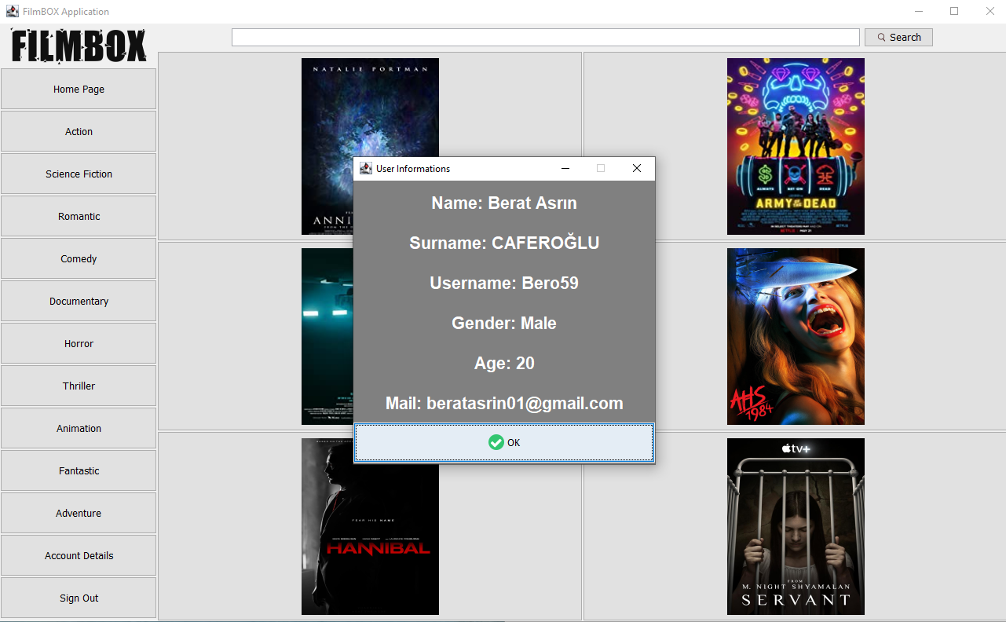Now let's try to **search** for contents:

Account Details

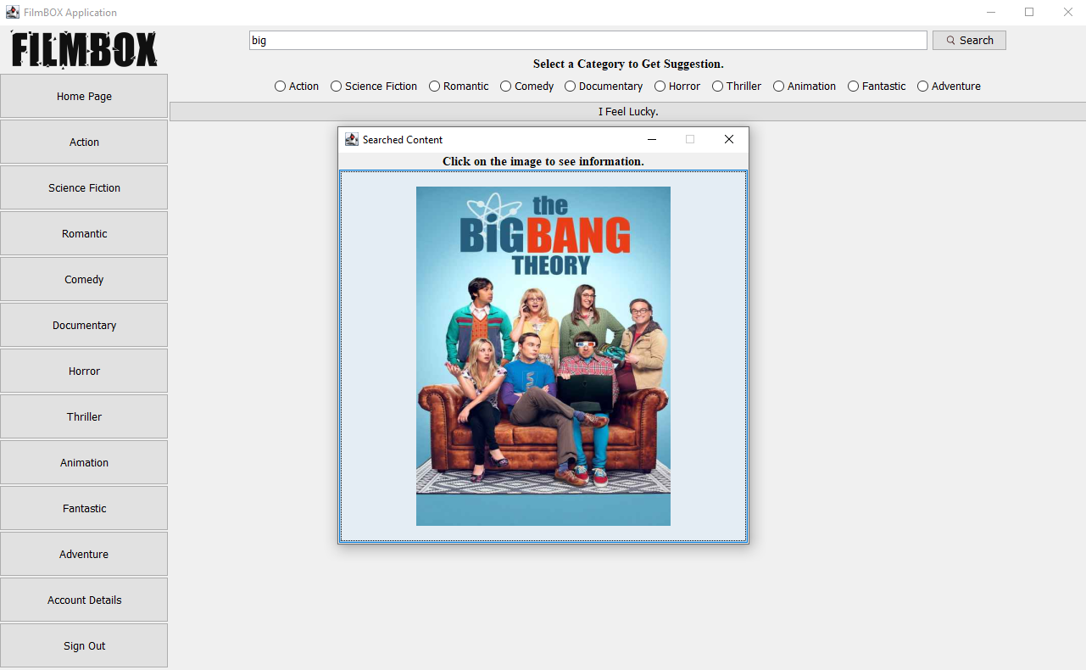The search button is active not only on the homepage but also when the categories button is clicked, so you can search anywhere you want also can search by the full name of the content or the words it contains.

Searching by Word

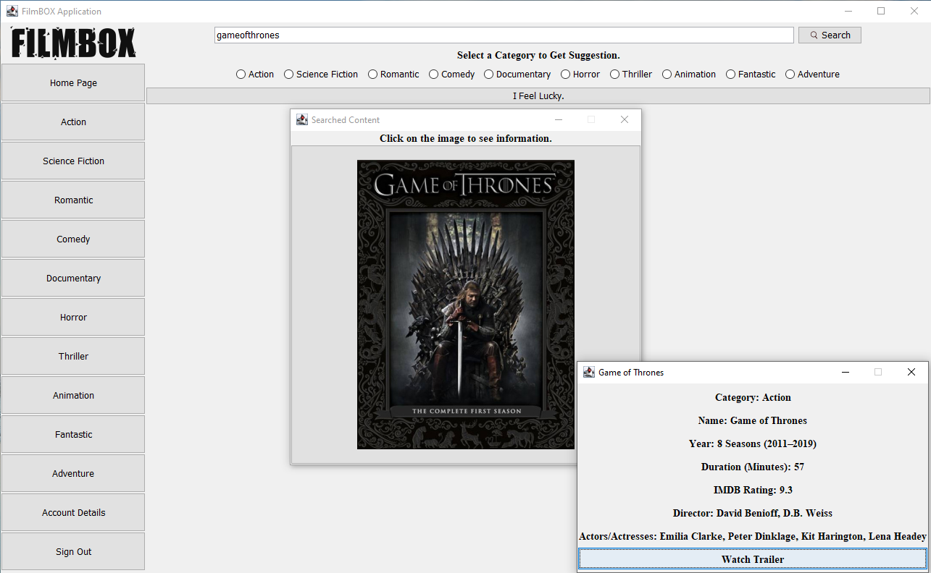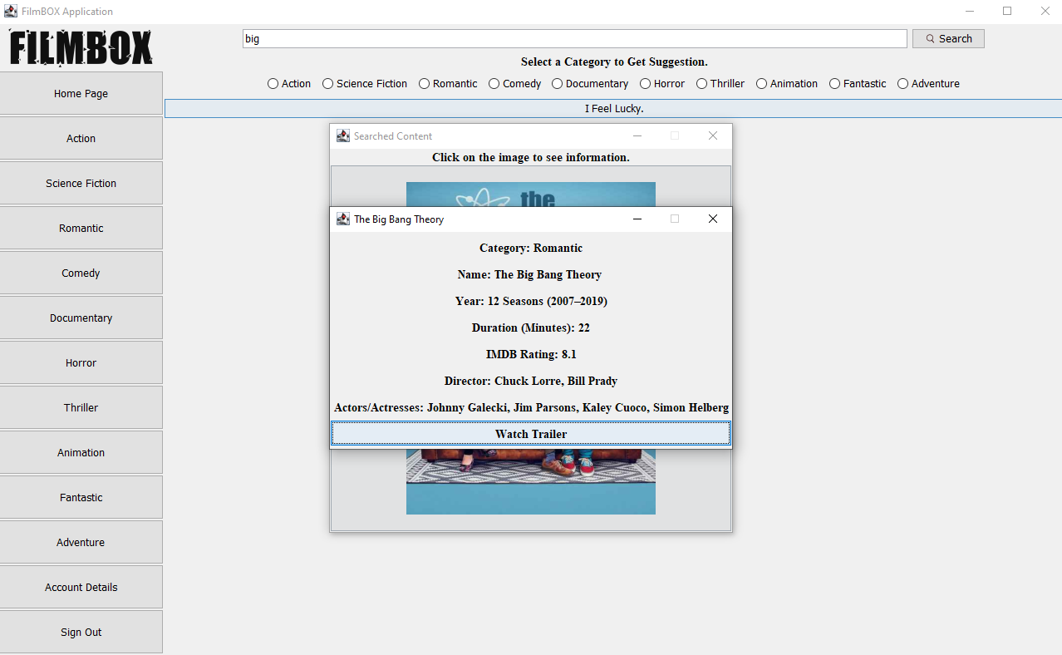

Searching by Full-Name and Its Info

Searched Content Info

Content searching part controls:

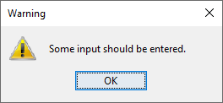

If nothing is entered in the search field.

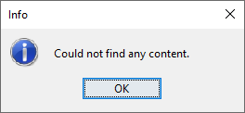

If a content name that is not in the application or a word that does not appear in the content name is entered

As can be seen, different optionpanes are used.

Now, if the **content suggestion** part is to be examined:

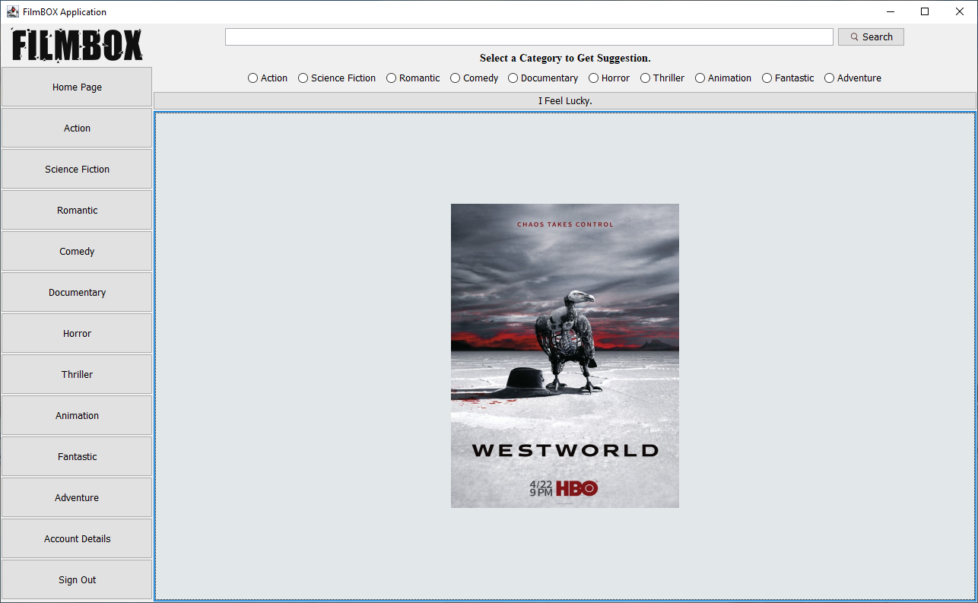After selecting a category then clicking, *I Feel Lucky*, random content is suggested from 6 different content under the relevant category.

Suggested Content-1 Based on Category

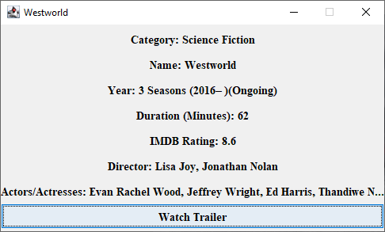

Suggested Content-1 Info

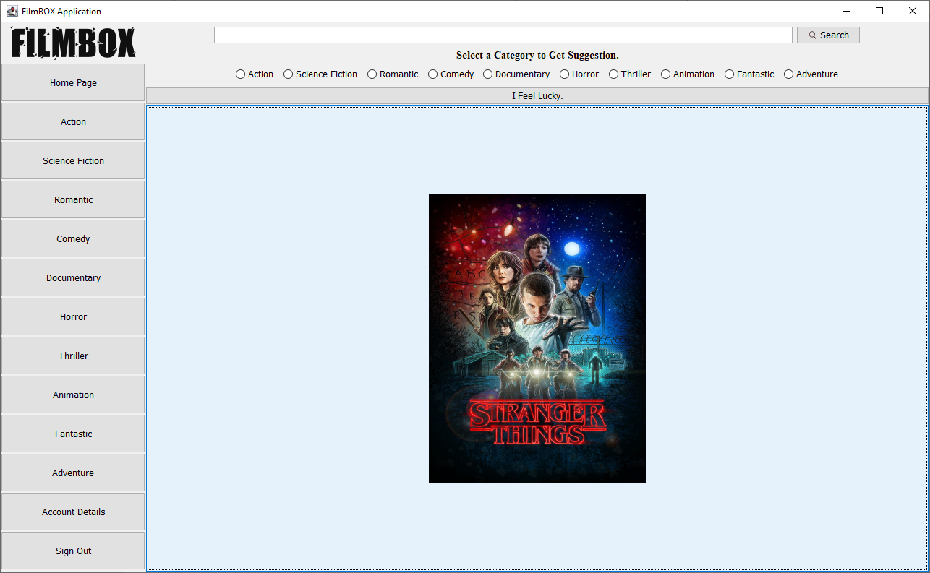

Suggested Content-2 Based on Category

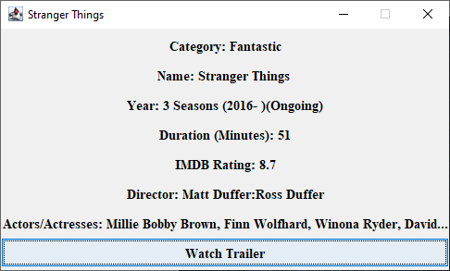

Suggested Content-2 Info

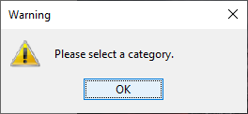Content suggesting part controls:

if category is not selected

***SIGN OUT***

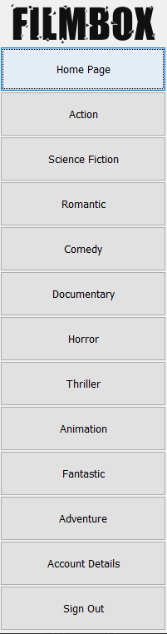

Application Screen Part

When the sign out button is clicked,

it returns to the entrance screen.

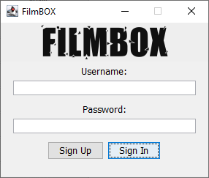

Entrance Screen

***Project Requirements***

GUI Application Based on File Operations:

Reading data from the file example

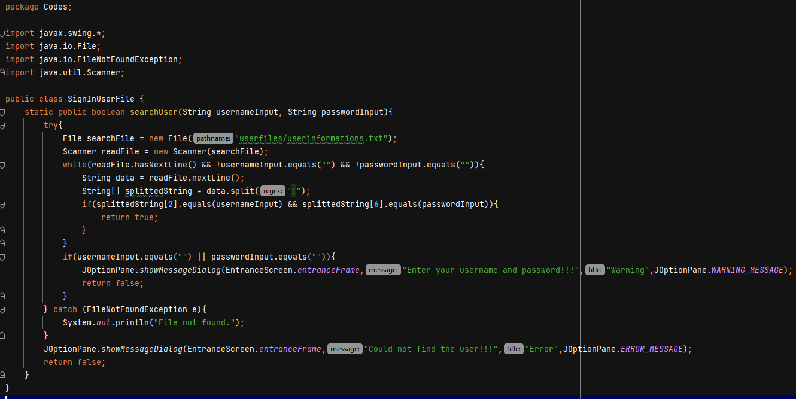

Writing data to file example

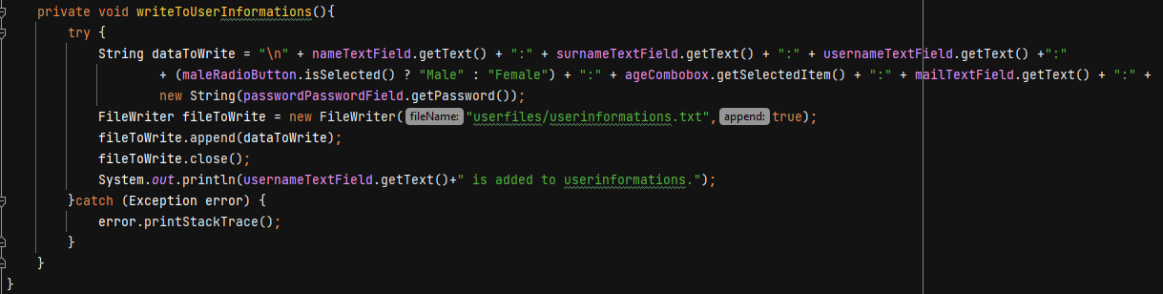

Screens/ Windows:

As seen in the above outputs, there are many different screens/windows;

* Splash Screen
* Sign In
* Sign Up
* Homepage
* 10 Different Categories
* Content Info(+ trailer link)
* Searched Content and Its Info
* Suggested Content and Its Info
* Account Details

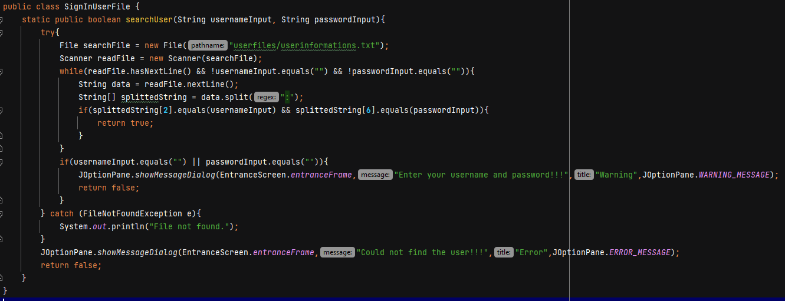Dialog boxes:

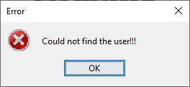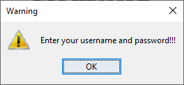

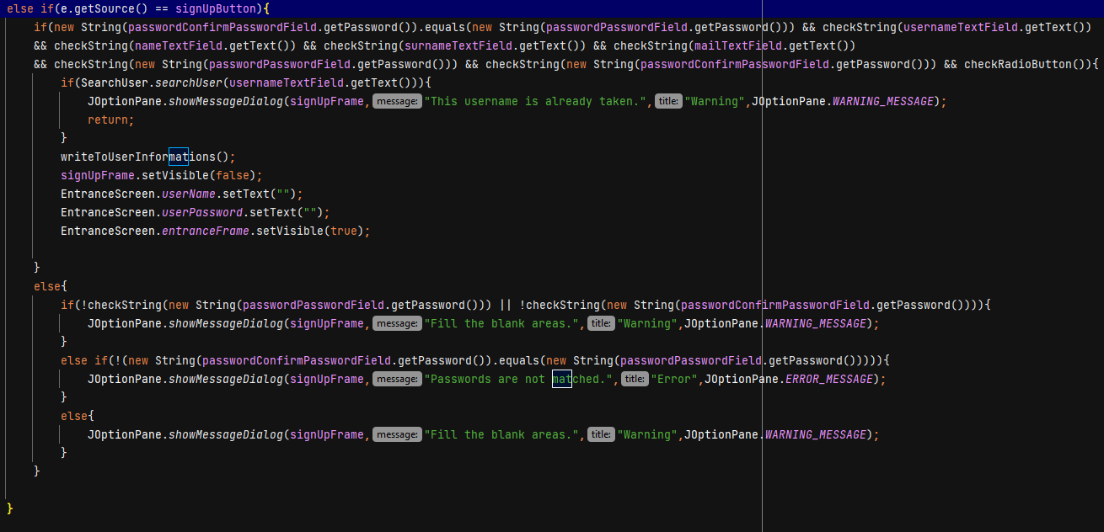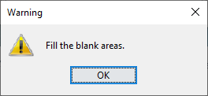

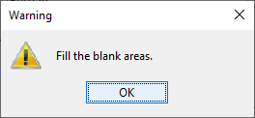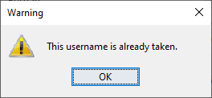

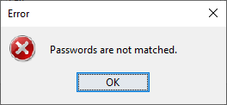

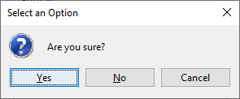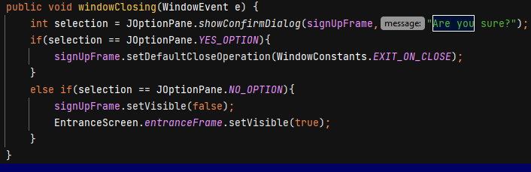

Other dialog boxes

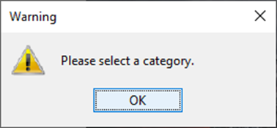



Controls:

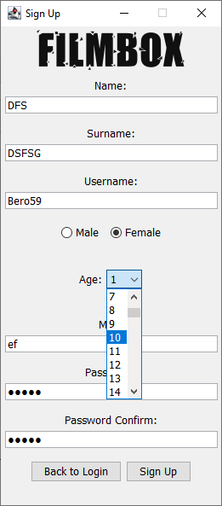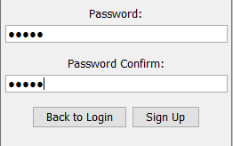

Combobox Control

Password Field Control



Radio Button Control

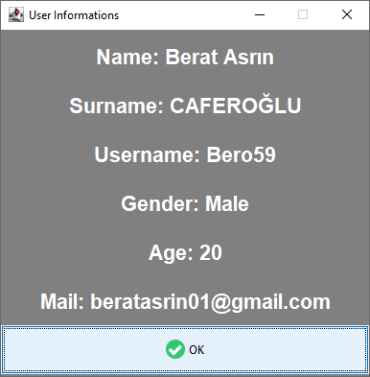

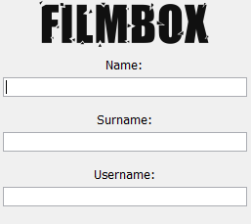

Text Field Control

Button Control

Exception Handling:

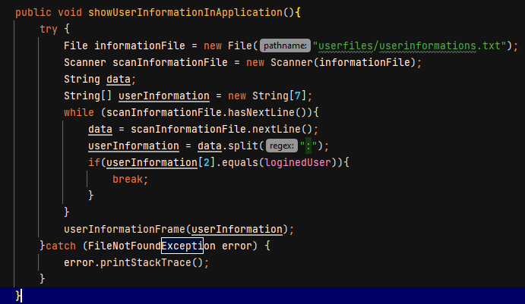

Event-Driven and Listener with Exception Handling:

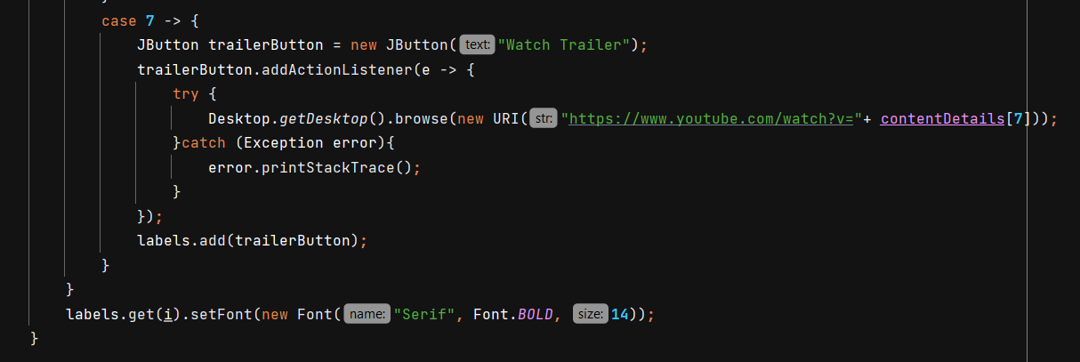

Encapsulation:

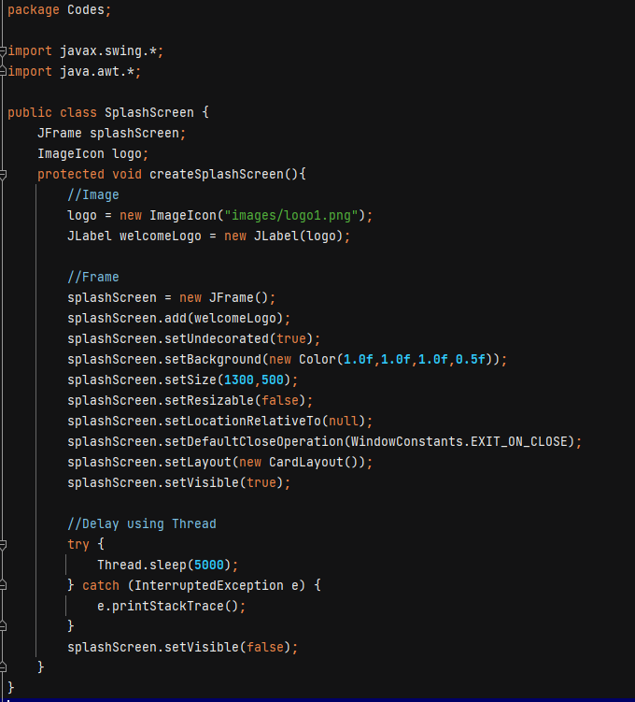

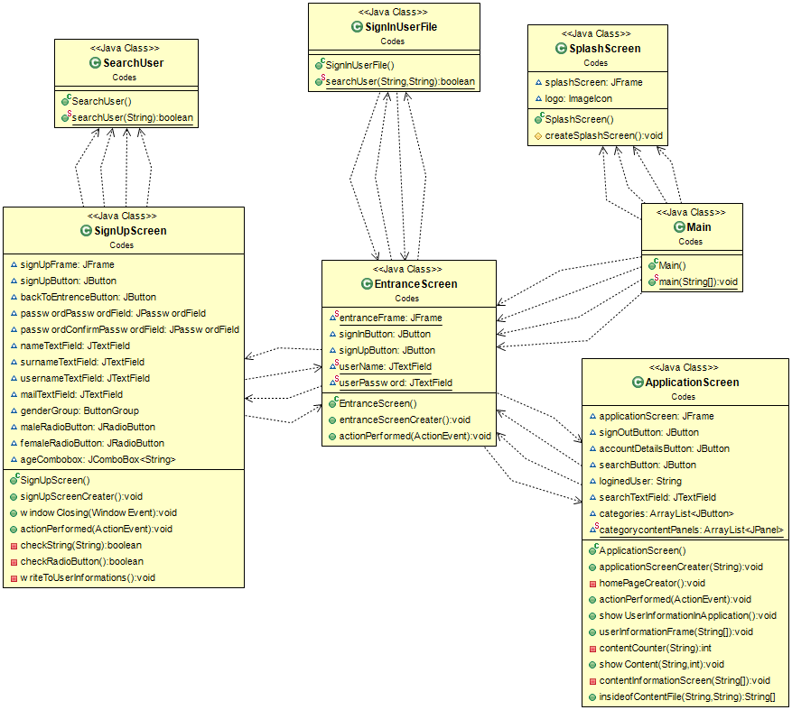UML Diagram:

UML Diagram

***Final Hierarchy and The Codes***

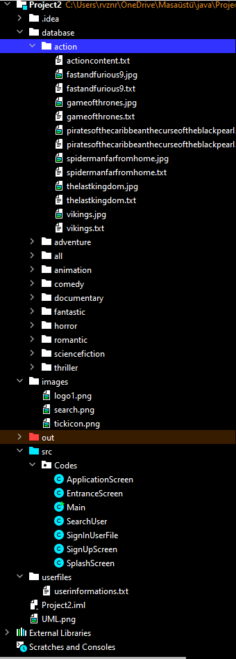

Content info files and posters in relevant category (action etc.)

Other categories

Package codes

User (sign up) info file

***Main***

package Codes**;**public class Main {  
 public static void main(String[] args) {  
 SplashScreen splashScreen = new SplashScreen()**;** splashScreen.createSplashScreen()**;** EntranceScreen entranceScreen = new EntranceScreen()**;** entranceScreen.entranceScreenCreater()**;** }  
}

***SplashScreen***

package Codes**;**import javax.swing.\***;**import java.awt.\***;**public class SplashScreen {  
 JFrame splashScreen**;** ImageIcon logo**;** protected void createSplashScreen(){  
 //Image  
 logo = new ImageIcon("images/logo1.png")**;** JLabel welcomeLogo = new JLabel(logo)**;** //Frame  
 splashScreen = new JFrame()**;** splashScreen.add(welcomeLogo)**;** splashScreen.setUndecorated(true)**;** splashScreen.setBackground(new Color(**1.0f,1.0f,1.0f,0.5f**))**;** splashScreen.setSize(**1300,500**)**;** splashScreen.setResizable(false)**;** splashScreen.setLocationRelativeTo(null)**;** splashScreen.setDefaultCloseOperation(WindowConstants.*EXIT_ON_CLOSE*)**;** splashScreen.setLayout(new CardLayout())**;** splashScreen.setVisible(true)**;** //Delay using Thread  
 try {  
 Thread.*sleep*(**5000**)**;** } catch (InterruptedException e) {  
 e.printStackTrace()**;** }  
 splashScreen.setVisible(false)**;** }  
}

***EntranceScreen***

package Codes**;**import javax.swing.\***;**import java.awt.\***;**import java.awt.event.ActionEvent**;**import java.awt.event.ActionListener**;**public class EntranceScreen implements ActionListener {  
 static JFrame *entranceFrame* = new JFrame("FilmBOX")**;** JButton signInButton**,** signUpButton**;** static JTextField *userName***,***userPassword***;** public void entranceScreenCreater(){  
  
 //UIManager  
 try {  
 UIManager.*setLookAndFeel*(UIManager.*getSystemLookAndFeelClassName*())**;** } catch (ClassNotFoundException | InstantiationException | IllegalAccessException | UnsupportedLookAndFeelException e) {  
 e.printStackTrace()**;** }  
  
 //Login Logo  
 ImageIcon logo = new ImageIcon("images/logo1.png")**;** Image logoReSized = logo.getImage().getScaledInstance(**200,200,** Image.*SCALE_SMOOTH*)**;** logo = new ImageIcon(logoReSized)**;** JLabel logoLabel = new JLabel(logo)**;** *entranceFrame*.add(logoLabel)**;** //Username Panel  
 JPanel userNamePanel = new JPanel()**;** userNamePanel.setLayout(new FlowLayout())**;** *entranceFrame*.add(userNamePanel)**;** //Username Label  
 JLabel userNameLabel = new JLabel("Username:")**;** userNamePanel.add(userNameLabel)**;** //Username Textfield  
 *userName* = new JTextField()**;** *userName*.setPreferredSize(new Dimension(**250,20**))**;** userNamePanel.add(*userName*)**;** //Password Panel  
 JPanel userPasswordPanel = new JPanel()**;** userPasswordPanel.setLayout(new FlowLayout())**;** *entranceFrame*.add(userPasswordPanel)**;** //Password Label  
 JLabel userPasswordLabel = new JLabel("Password:")**;** userPasswordPanel.add(userPasswordLabel)**;** //Password Textfield  
 *userPassword* = new JPasswordField()**;** *userPassword*.setPreferredSize(new Dimension(**250,20**))**;** userPasswordPanel.add(*userPassword*)**;** //Button Panel  
 JPanel entrancePanel = new JPanel()**;** entrancePanel.setLayout(new FlowLayout())**;** *entranceFrame*.add(entrancePanel)**;** //Sign up Button  
 signUpButton = new JButton("Sign Up")**;** signUpButton.addActionListener(this)**;** entrancePanel.add(signUpButton)**;** //Sign in Button  
 signInButton = new JButton("Sign In")**;** signInButton.addActionListener(this)**;** entrancePanel.add(signInButton)**;** //Frame  
 *entranceFrame*.setDefaultCloseOperation(WindowConstants.*EXIT_ON_CLOSE*)**;** *entranceFrame*.setLayout(new GridLayout(**4,1**))**;** *entranceFrame*.setSize(**300,250**)**;** *entranceFrame*.setLocationRelativeTo(null)**;** *entranceFrame*.setResizable(false)**;** *entranceFrame*.setVisible(true)**;** }  
  
 @Override  
 public void actionPerformed(ActionEvent e) {  
 if(e.getSource() == signInButton){  
 boolean checkFile**;** checkFile = SignInUserFile.*searchUser*(*userName*.getText()**,***userPassword*.getText())**;** if(checkFile){  
 *entranceFrame*.setVisible(false)**;** ApplicationScreen applicationScreen = new ApplicationScreen()**;** applicationScreen.applicationScreenCreater(*userName*.getText())**;** }  
  
 }  
 else if(e.getSource() == signUpButton){  
 *entranceFrame*.setVisible(false)**;** SignUpScreen signUpScreen = new SignUpScreen()**;** signUpScreen.signUpScreenCreater()**;** }  
 }  
  
}

***SearchUser***

package Codes**;**import java.io.File**;**import java.util.Scanner**;**public class SearchUser {  
 static public boolean searchUser(String username){  
 try{  
 File file = new File("userfiles/userinformations.txt")**;** Scanner scanner = new Scanner(file)**;** String[] information**;** String line**;** while (scanner.hasNextLine()){  
 line = scanner.nextLine()**;** information = line.split(":")**;** if(username.equals(information[**2**])){  
 return true**;** }  
 }  
 } catch (Exception error) {  
 error.printStackTrace()**;** }  
 return false**;** }  
}

***SignUpScreen***

package Codes**;**import javax.swing.\***;**import java.awt.\***;**import java.awt.event.ActionEvent**;**import java.awt.event.ActionListener**;**import java.awt.event.WindowAdapter**;**import java.awt.event.WindowEvent**;**import java.io.\***;**public class SignUpScreen extends WindowAdapter implements ActionListener {  
 JFrame signUpFrame = new JFrame("Sign Up")**;** JButton signUpButton**,** backToEntrenceButton**;** JPasswordField passwordPasswordField**,** passwordConfirmPasswordField**;** JTextField nameTextField**,** surnameTextField**,** usernameTextField**,** mailTextField**;** ButtonGroup genderGroup**;** JRadioButton maleRadioButton**,**femaleRadioButton**;** JComboBox <String> ageCombobox**;** public void signUpScreenCreater(){  
 //SignUp Logo Label  
 ImageIcon logo = new ImageIcon("images/logo1.png")**;** Image logoReSized = logo.getImage().getScaledInstance(**200,200,** Image.*SCALE_SMOOTH*)**;** logo = new ImageIcon(logoReSized)**;** JLabel logoLabel = new JLabel(logo)**;** signUpFrame.add(logoLabel)**;** //Name Label  
 JLabel nameLabel = new JLabel("Name:")**;** nameLabel.setVerticalAlignment(JLabel.*CENTER*)**;** nameLabel.setHorizontalAlignment(JLabel.*CENTER*)**;** //Name TextField  
 nameTextField = new JTextField()**;** nameTextField.setPreferredSize(new Dimension(**250,20**))**;** //Name Panel  
 JPanel namePanel = new JPanel()**;** namePanel.setLayout(new FlowLayout())**;** namePanel.add(nameLabel)**;** namePanel.add(nameTextField)**;** signUpFrame.add(namePanel)**;** //Surname Label  
 JLabel surnameLabel = new JLabel("Surname:")**;** surnameLabel.setVerticalAlignment(JLabel.*CENTER*)**;** surnameLabel.setHorizontalAlignment(JLabel.*CENTER*)**;** //Surname TextField  
 surnameTextField = new JTextField()**;** surnameTextField.setPreferredSize(new Dimension(**250,20**))**;** //Surname Panel  
 JPanel surnamePanel = new JPanel()**;** surnamePanel.setLayout(new FlowLayout())**;** surnamePanel.add(surnameLabel)**;** surnamePanel.add(surnameTextField)**;** signUpFrame.add(surnamePanel)**;** //Username Label  
 JLabel usernameLabel = new JLabel("Username:")**;** usernameLabel.setHorizontalAlignment(JLabel.*CENTER*)**;** usernameLabel.setVerticalAlignment(JLabel.*CENTER*)**;** //Username textfield  
 usernameTextField = new JTextField()**;** usernameTextField.setPreferredSize(new Dimension(**250,20**))**;** //Username input panel  
 JPanel usernameInput = new JPanel()**;** usernameInput.add(usernameLabel)**;** usernameInput.add(usernameTextField)**;** usernameInput.setLayout(new FlowLayout())**;** signUpFrame.add(usernameInput)**;** //Gender RadioButton  
 maleRadioButton = new JRadioButton("Male")**;** femaleRadioButton = new JRadioButton("Female")**;** genderGroup = new ButtonGroup()**;** genderGroup.add(maleRadioButton)**;** genderGroup.add(femaleRadioButton)**;** //GenderPanel  
 JPanel genderPanel = new JPanel()**;** genderPanel.setLayout(new FlowLayout())**;** genderPanel.add(maleRadioButton)**;** genderPanel.add(femaleRadioButton)**;** signUpFrame.add(genderPanel)**;** //Age Panel  
 String[] ages = new String[**99**]**;** for (int i=**1;**i<**100;**i++){  
 ages[i-**1**] = Integer.*toString*(i)**;** }  
 ageCombobox = new JComboBox<>(ages)**;** JLabel ageLabel = new JLabel("Age:")**;** ageLabel.setVerticalAlignment(JLabel.*CENTER*)**;** ageLabel.setHorizontalAlignment(JLabel.*CENTER*)**;** JPanel agePanel = new JPanel()**;** agePanel.setLayout(new FlowLayout())**;** agePanel.add(ageLabel)**;** agePanel.add(ageCombobox)**;** signUpFrame.add(agePanel)**;** //Mail Label  
 JLabel mailLabel = new JLabel("Mail:")**;** mailLabel.setVerticalAlignment(JLabel.*CENTER*)**;** mailLabel.setHorizontalAlignment(JLabel.*CENTER*)**;** //Mail TextField  
 mailTextField = new JTextField()**;** mailTextField.setPreferredSize(new Dimension(**250,20**))**;** //Mail Panel  
 JPanel mailPanel = new JPanel()**;** mailPanel.setLayout(new FlowLayout())**;** mailPanel.add(mailLabel)**;** mailPanel.add(mailTextField)**;** signUpFrame.add(mailPanel)**;** //Password Label  
 JLabel passwordLabel = new JLabel("Password:")**;** passwordLabel.setVerticalAlignment(JLabel.*CENTER*)**;** passwordLabel.setHorizontalAlignment(JLabel.*CENTER*)**;** //Password TextField  
 passwordPasswordField = new JPasswordField()**;** passwordPasswordField.setPreferredSize(new Dimension(**250,20**))**;** //Password Confirm Label  
 JLabel passwordConfirmLabel = new JLabel("Password Confirm:")**;** passwordConfirmLabel.setHorizontalAlignment(JLabel.*CENTER*)**;** passwordConfirmLabel.setVerticalAlignment(JLabel.*CENTER*)**;** //Password Confirm TextField  
 passwordConfirmPasswordField = new JPasswordField()**;** passwordConfirmPasswordField.setPreferredSize(new Dimension(**250,20**))**;** //Password Panel  
 JPanel passwordPanel = new JPanel()**;** passwordPanel.setLayout(new FlowLayout())**;** passwordPanel.add(passwordLabel)**;** passwordPanel.add(passwordPasswordField)**;** signUpFrame.add(passwordPanel)**;** //Password Confirm Panel  
 JPanel passwordConfirmPanel = new JPanel()**;** passwordConfirmPanel.add(passwordConfirmLabel)**;** passwordConfirmPanel.add(passwordConfirmPasswordField)**;** signUpFrame.add(passwordConfirmPanel)**;** //Buttons  
 signUpButton = new JButton("Sign Up")**;** backToEntrenceButton = new JButton("Back to Login")**;** signUpButton.addActionListener(this)**;** backToEntrenceButton.addActionListener(this)**;** //Button Panel  
 JPanel buttonPanel = new JPanel()**;** buttonPanel.setLayout(new FlowLayout())**;** buttonPanel.add(backToEntrenceButton)**;** buttonPanel.add(signUpButton)**;** signUpFrame.add(buttonPanel)**;** //Frame  
 signUpFrame.setDefaultCloseOperation(WindowConstants.*DO_NOTHING_ON_CLOSE*)**;** signUpFrame.addWindowListener(this)**;** signUpFrame.setLayout(new GridLayout(**10,1**))**;** signUpFrame.setSize(**275,600**)**;** signUpFrame.setLocationRelativeTo(null)**;** signUpFrame.setResizable(false)**;** signUpFrame.setVisible(true)**;** }  
  
 @Override  
 public void windowClosing(WindowEvent e) {  
 int selection = JOptionPane.*showConfirmDialog*(signUpFrame**,**"Are you sure?")**;** if(selection == JOptionPane.*YES_OPTION*){  
 signUpFrame.setDefaultCloseOperation(WindowConstants.*EXIT_ON_CLOSE*)**;** }  
 else if(selection == JOptionPane.*NO_OPTION*){  
 signUpFrame.setVisible(false)**;** EntranceScreen.*entranceFrame*.setVisible(true)**;** }  
 }  
  
 @Override  
 public void actionPerformed(ActionEvent e) {  
 if(e.getSource() == backToEntrenceButton){  
 signUpFrame.setVisible(false)**;** EntranceScreen.*userName*.setText("")**;** EntranceScreen.*userPassword*.setText("")**;** EntranceScreen.*entranceFrame*.setVisible(true)**;** }  
 else if(e.getSource() == signUpButton){  
 if(new String(passwordConfirmPasswordField.getPassword()).equals(new String(passwordPasswordField.getPassword())) && checkString(usernameTextField.getText())  
 && checkString(nameTextField.getText()) && checkString(surnameTextField.getText()) && checkString(mailTextField.getText())  
 && checkString(new String(passwordPasswordField.getPassword())) && checkString(new String(passwordConfirmPasswordField.getPassword())) && checkRadioButton()){  
 if(SearchUser.*searchUser*(usernameTextField.getText())){  
 JOptionPane.*showMessageDialog*(signUpFrame**,**"This username is already taken."**,**"Warning"**,**JOptionPane.*WARNING_MESSAGE*)**;** return**;** }  
 writeToUserInformations()**;** signUpFrame.setVisible(false)**;** EntranceScreen.*userName*.setText("")**;** EntranceScreen.*userPassword*.setText("")**;** EntranceScreen.*entranceFrame*.setVisible(true)**;** }  
 else{  
 if(!checkString(new String(passwordPasswordField.getPassword())) || !checkString(new String(passwordConfirmPasswordField.getPassword()))){  
 JOptionPane.*showMessageDialog*(signUpFrame**,**"Fill the blank areas."**,**"Warning"**,**JOptionPane.*WARNING_MESSAGE*)**;** }  
 else if(!(new String(passwordConfirmPasswordField.getPassword()).equals(new String(passwordPasswordField.getPassword())))){  
 JOptionPane.*showMessageDialog*(signUpFrame**,**"Passwords are not matched."**,**"Error"**,**JOptionPane.*ERROR_MESSAGE*)**;** }  
 else{  
 JOptionPane.*showMessageDialog*(signUpFrame**,**"Fill the blank areas."**,**"Warning"**,**JOptionPane.*WARNING_MESSAGE*)**;** }  
 }  
  
 }  
 }  
  
 private boolean checkString(String toCheck){  
 return !toCheck.equals("")**;** }  
  
 private boolean checkRadioButton(){  
 return maleRadioButton.isSelected() || femaleRadioButton.isSelected()**;** }  
  
 private void writeToUserInformations(){  
 try {  
 String dataToWrite = "\n" + nameTextField.getText() + ":" + surnameTextField.getText() + ":" + usernameTextField.getText() +":"  
 + (maleRadioButton.isSelected() ? "Male" : "Female") + ":" + ageCombobox.getSelectedItem() + ":" + mailTextField.getText() + ":" +  
 new String(passwordPasswordField.getPassword())**;** FileWriter fileToWrite = new FileWriter("userfiles/userinformations.txt"**,**true)**;** fileToWrite.append(dataToWrite)**;** fileToWrite.close()**;** System.*out*.println(usernameTextField.getText()+" is added to userinformations.")**;** }catch (Exception error) {  
 error.printStackTrace()**;** }  
 }  
}

***SignInScreen***

package Codes**;**import javax.swing.\***;**import java.io.File**;**import java.io.FileNotFoundException**;**import java.util.Scanner**;**public class SignInUserFile {  
 static public boolean searchUser(String usernameInput**,** String passwordInput){  
 try{  
 File searchFile = new File("userfiles/userinformations.txt")**;** Scanner readFile = new Scanner(searchFile)**;** while(readFile.hasNextLine() && !usernameInput.equals("") && !passwordInput.equals("")){  
 String data = readFile.nextLine()**;** String[] splittedString = data.split(":")**;** if(splittedString[**2**].equals(usernameInput) && splittedString[**6**].equals(passwordInput)){  
 return true**;** }  
 }  
 if(usernameInput.equals("") || passwordInput.equals("")){  
 JOptionPane.*showMessageDialog*(EntranceScreen.*entranceFrame***,**"Enter your username and password!!!"**,**"Warning"**,**JOptionPane.*WARNING_MESSAGE*)**;** return false**;** }  
 } catch (FileNotFoundException e){  
 System.*out*.println("File not found.")**;** }  
 JOptionPane.*showMessageDialog*(EntranceScreen.*entranceFrame***,**"Could not find the user!!!"**,**"Error"**,**JOptionPane.*ERROR_MESSAGE*)**;** return false**;** }  
}

***ApplicationScreen***

package Codes**;**import javax.swing.\***;**import java.awt.\***;**import java.awt.event.ActionEvent**;**import java.awt.event.ActionListener**;**import java.io.File**;**import java.io.FileNotFoundException**;**import java.net.URI**;**import java.util.ArrayList**;**import java.util.Random**;**import java.util.Scanner**;**// Inside of application after logining in  
public class ApplicationScreen extends Container implements ActionListener {  
 JFrame applicationScreen = new JFrame("FilmBOX Application")**;** JButton signOutButton = new JButton("Sign Out")**;** JButton accountDetailsButton = new JButton("Account Details")**;** JButton searchButton**;** String loginedUser = ""**;** JTextField searchTextField**;** ArrayList <JButton> categories = new ArrayList<>()**;** static ArrayList <JPanel> *categorycontentPanels* = new ArrayList<>()**;** // Frame creater method of application  
 public void applicationScreenCreater(String loginedUser){  
 this.loginedUser = loginedUser**;** //Search Panel  
 searchTextField = new JTextField()**;** searchTextField.setPreferredSize(new Dimension(**800,23**))**;** ImageIcon searchImageIcon = new ImageIcon("images/search.png")**;** Image searchImage = searchImageIcon.getImage().getScaledInstance(**13,13,** Image.*SCALE_SMOOTH*)**;** searchImageIcon = new ImageIcon(searchImage)**;** searchButton = new JButton("Search"**,**searchImageIcon)**;** searchButton.addActionListener(this)**;** JPanel searchPanel = new JPanel()**;** searchPanel.add(searchTextField)**;** searchPanel.add(searchButton)**;** searchPanel.setLayout(new FlowLayout())**;** //Center Panel  
 JPanel centerPanel = new JPanel()**;** centerPanel.setLayout(new BorderLayout())**;** centerPanel.add(searchPanel**,**BorderLayout.*NORTH*)**;** applicationScreen.add(centerPanel**,**BorderLayout.*CENTER*)**;** //Categories  
 categories.add(new JButton("Home Page"))**;** categories.add(new JButton("Action"))**;** categories.add(new JButton("Science Fiction"))**;** categories.add(new JButton("Romantic"))**;** categories.add(new JButton("Comedy"))**;** categories.add(new JButton("Documentary"))**;** categories.add(new JButton("Horror"))**;** categories.add(new JButton("Thriller"))**;** categories.add(new JButton("Animation"))**;** categories.add(new JButton("Fantastic"))**;** categories.add(new JButton("Adventure"))**;** categories.add(accountDetailsButton)**;** categories.add(signOutButton)**;** //Logo Label  
 ImageIcon logo = new ImageIcon("images/logo1.png")**;** Image logoReSized = logo.getImage().getScaledInstance(**200,200,** Image.*SCALE_SMOOTH*)**;** logo = new ImageIcon(logoReSized)**;** JLabel logoLabel = new JLabel(logo)**;** //Category Panel  
 JPanel categoryPanel = new JPanel()**;** categoryPanel.setLayout(new GridLayout(**14,1**))**;** categoryPanel.add(logoLabel)**;** for (JButton temp: categories) {  
 categoryPanel.add(temp)**;** temp.addActionListener(this)**;** }  
  
 applicationScreen.add(categoryPanel**,**BorderLayout.*WEST*)**;** //Category Panels  
 int i**;** for (i=**0;**i<**11;**i++){  
 *categorycontentPanels*.add(new JPanel())**;** }  
  
 //Category Layout Setups  
 for (JPanel temp: *categorycontentPanels*){  
 temp.removeAll()**;** }  
  
 homePageCreator()**;** showContent("action"**,1**)**;** showContent("sciencefiction"**,2**)**;** showContent("romantic"**,3**)**;** showContent("comedy"**,4**)**;** showContent("documentary"**,5**)**;** showContent("horror"**,6**)**;** showContent("thriller"**,7**)**;** showContent("animation"**,8**)**;** showContent("fantastic"**,9**)**;** showContent("adventure"**,10**)**;** JPanel contentShowPanel = new JPanel()**;** contentShowPanel.setLayout(new CardLayout())**;** contentShowPanel.add(*categorycontentPanels*.get(**0**))**;** contentShowPanel.add(*categorycontentPanels*.get(**1**))**;** contentShowPanel.add(*categorycontentPanels*.get(**2**))**;** contentShowPanel.add(*categorycontentPanels*.get(**3**))**;** contentShowPanel.add(*categorycontentPanels*.get(**4**))**;** contentShowPanel.add(*categorycontentPanels*.get(**5**))**;** contentShowPanel.add(*categorycontentPanels*.get(**6**))**;** contentShowPanel.add(*categorycontentPanels*.get(**7**))**;** contentShowPanel.add(*categorycontentPanels*.get(**8**))**;** contentShowPanel.add(*categorycontentPanels*.get(**9**))**;** contentShowPanel.add(*categorycontentPanels*.get(**10**))**;** centerPanel.add(contentShowPanel**,**BorderLayout.*CENTER*)**;** //Frame  
 applicationScreen.setDefaultCloseOperation(WindowConstants.*EXIT_ON_CLOSE*)**;** applicationScreen.setSize(**1300,800**)**;** applicationScreen.setMinimumSize(new Dimension(**1300,800**))**;** applicationScreen.setLocationRelativeTo(null)**;** applicationScreen.setVisible(true)**;** }  
  
 // The panel that is used to get random content  
 private void homePageCreator() { // Home Page designation  
 *categorycontentPanels*.get(**0**).setLayout(new BorderLayout())**;** //North Panel  
 JPanel northPanel = new JPanel()**;** northPanel.setLayout(new BorderLayout())**;** //North Panel of North Panel  
 JPanel northOfNorthPanel = new JPanel()**;** northOfNorthPanel.setLayout(new FlowLayout())**;** //RadioButtons  
 ArrayList <JRadioButton> categoryRadios = new ArrayList<>()**;** ButtonGroup radioButtonGroup = new ButtonGroup()**;** for(int i=**0;**i<**10;**i++){  
 switch (i){  
 case **0** -> categoryRadios.add(new JRadioButton("Action"))**;** case **1** -> categoryRadios.add(new JRadioButton("Science Fiction"))**;** case **2** -> categoryRadios.add(new JRadioButton("Romantic"))**;** case **3** -> categoryRadios.add(new JRadioButton("Comedy"))**;** case **4** -> categoryRadios.add(new JRadioButton("Documentary"))**;** case **5** -> categoryRadios.add(new JRadioButton("Horror"))**;** case **6** -> categoryRadios.add(new JRadioButton("Thriller"))**;** case **7** -> categoryRadios.add(new JRadioButton("Animation"))**;** case **8** -> categoryRadios.add(new JRadioButton("Fantastic"))**;** case **9** -> categoryRadios.add(new JRadioButton("Adventure"))**;** }  
 radioButtonGroup.add(categoryRadios.get(i))**;** northOfNorthPanel.add(categoryRadios.get(i))**;** }  
 JLabel categoryLabel = new JLabel("Select a Category to Get Suggestion.")**;** categoryLabel.setFont(new Font("Serif"**,** Font.*BOLD***, 14**))**;** categoryLabel.setVerticalAlignment(JLabel.*CENTER*)**;** categoryLabel.setHorizontalAlignment(JLabel.*CENTER*)**;** northPanel.add(categoryLabel**,** BorderLayout.*NORTH*)**;** northPanel.add(northOfNorthPanel**,**BorderLayout.*CENTER*)**;** JButton luckyButton = new JButton("I Feel Lucky.")**;** luckyButton.addActionListener(e -> {  
 int flag = **0;** String categoryInfo=""**;** for(JRadioButton temp: categoryRadios){  
 if(temp.isSelected()){  
 categoryInfo = temp.getText().replaceAll(" "**,**"").toLowerCase()**;** flag = **1;** break**;** }  
 }  
 if(flag == **1**){  
 try {  
 String line**;** String[] getName**;** ArrayList <String> relatedContent = new ArrayList<>()**;** File allFile = new File("database/all/allcontent.txt")**;** Scanner scanAllFile = new Scanner(allFile)**;** while (scanAllFile.hasNextLine()){  
 line = scanAllFile.nextLine()**;** if(line.contains(categoryInfo)){  
 getName = line.split(" ")**;** relatedContent.add(getName[**0**])**;** }  
 }  
 try {  
 Random randNumberGenerator = new Random()**;** int randomNumber = randNumberGenerator.nextInt(relatedContent.size())**;** ImageIcon randomContent = new ImageIcon("database/"+categoryInfo+"/"+relatedContent.get(randomNumber)+".jpg")**;** Image reSized = randomContent.getImage().getScaledInstance(**300,400,**Image.*SCALE_SMOOTH*)**;** randomContent = new ImageIcon(reSized)**;** *categorycontentPanels*.get(**0**).removeAll()**;** homePageCreator()**;** JButton contentButton = new JButton(randomContent)**;** String finalCategoryInfo = categoryInfo**;** contentButton.addActionListener(e1 -> {  
 try {  
 String[] data**;** data = insideofContentFile(finalCategoryInfo**,**relatedContent.get(randomNumber))**;** contentInformationScreen(data)**;** }catch (Exception error){  
 error.printStackTrace()**;** }  
  
 })**;** *categorycontentPanels*.get(**0**).add(contentButton**,**BorderLayout.*CENTER*)**;** *categorycontentPanels*.get(**0**).setVisible(false)**;** *categorycontentPanels*.get(**0**).setVisible(true)**;** }catch (Exception insideError){  
 insideError.printStackTrace()**;** }  
 }catch (Exception error){  
 error.printStackTrace()**;** }  
 }  
 else{  
 JOptionPane.*showMessageDialog*(applicationScreen**,**"Please select a category."**,**"Warning"**,**JOptionPane.*WARNING_MESSAGE*)**;** }  
 })**;** northPanel.add(luckyButton**,**BorderLayout.*SOUTH*)**;** *categorycontentPanels*.get(**0**).add(northPanel**,** BorderLayout.*NORTH*)**;** }  
  
 // Action listeners of components  
 @Override  
 public void actionPerformed(ActionEvent e) {  
 if (e.getSource() == signOutButton){  
 EntranceScreen.*userName*.setText("")**;** EntranceScreen.*userPassword*.setText("")**;** applicationScreen.setVisible(false)**;** EntranceScreen.*entranceFrame*.setVisible(true)**;** }  
 else if (e.getSource() == accountDetailsButton){  
 showUserInformationInApplication()**;** }  
 else if(e.getSource() == searchButton){  
 if(searchTextField.getText().equals("")){  
 JOptionPane.*showMessageDialog*(applicationScreen**,**"Some input should be entered."**,**"Warning"**,**JOptionPane.*WARNING_MESSAGE*)**;** }  
 else{  
 JFrame searchFrame = new JFrame("Search")**;** searchFrame.setDefaultCloseOperation(WindowConstants.*DISPOSE_ON_CLOSE*)**;** try {  
 int flag=**0;** File searchDatabase = new File("database/all/allcontent.txt")**;** Scanner scanDatabase = new Scanner(searchDatabase)**;** String[] words**;** String[] infoOfContent = new String[**2**]**;** words = searchTextField.getText().split(" ")**;** loop:  
 while (scanDatabase.hasNextLine()){  
 infoOfContent = scanDatabase.nextLine().split(" ")**;** for(String temp: words){  
 if(infoOfContent[**0**].contains(temp)){  
 flag = **1;** break loop**;** }  
 }  
 }  
 scanDatabase.close()**;** if(flag == **1**){  
 try {  
 ImageIcon searchedContent = new ImageIcon("database/"+ infoOfContent[**1**] +"/"+ infoOfContent[**0**] +".jpg")**;** Image reSized = searchedContent.getImage().getScaledInstance(**300,400,**Image.*SCALE_SMOOTH*)**;** searchedContent = new ImageIcon(reSized)**;** JButton searchedContentButton = new JButton(searchedContent)**;** String[] finalInfoOfContent = infoOfContent**;** searchedContentButton.addActionListener(e1 -> contentInformationScreen(insideofContentFile(finalInfoOfContent[**1**]**,** finalInfoOfContent[**0**])))**;** //Frame  
 JFrame searchedContentFrame = new JFrame("Searched Content")**;** searchedContentFrame.setLayout(new BorderLayout())**;** searchedContentFrame.setDefaultCloseOperation(WindowConstants.*DISPOSE_ON_CLOSE*)**;** searchedContentFrame.add(searchedContentButton**,**BorderLayout.*CENTER*)**;** JLabel infoLabel = new JLabel("Click on the image to see information.")**;** infoLabel.setFont(new Font("Serif"**,** Font.*BOLD***, 14**))**;** infoLabel.setHorizontalAlignment(JLabel.*CENTER*)**;** infoLabel.setVerticalAlignment(JLabel.*CENTER*)**;** searchedContentFrame.add(infoLabel**,**BorderLayout.*NORTH*)**;** searchedContentFrame.setSize(**500,500**)**;** searchedContentFrame.setLocationRelativeTo(null)**;** searchedContentFrame.setResizable(false)**;** searchedContentFrame.setVisible(true)**;** }catch (Exception error){  
 error.printStackTrace()**;** }  
 }  
 else{  
 JOptionPane.*showMessageDialog*(applicationScreen**,**"Could not find any content."**,**"Info"**,**JOptionPane.*INFORMATION_MESSAGE*)**;** }  
  
 }catch (Exception error){  
 error.printStackTrace()**;** }  
 }  
 }  
 else if (e.getSource() == categories.get(**0**)){  
 int i=**0;** while(i!=**11**){  
 *categorycontentPanels*.get(i).setVisible(i == **0**)**;** i++**;** }  
 }  
 else if (e.getSource() == categories.get(**1**)){  
 int i=**0;** while(i!=**11**){  
 *categorycontentPanels*.get(i).setVisible(i == **1**)**;** i++**;** }  
 }  
 else if (e.getSource() == categories.get(**2**)){  
 int i=**0;** while(i!=**11**){  
 *categorycontentPanels*.get(i).setVisible(i == **2**)**;** i++**;** }  
 }  
 else if (e.getSource() == categories.get(**3**)){  
 int i=**0;** while(i!=**11**){  
 *categorycontentPanels*.get(i).setVisible(i == **3**)**;** i++**;** }  
 }  
 else if (e.getSource() == categories.get(**4**)){  
 int i=**0;** while(i!=**11**){  
 *categorycontentPanels*.get(i).setVisible(i == **4**)**;** i++**;** }  
 }  
 else if (e.getSource() == categories.get(**5**)){  
 int i=**0;** while(i!=**11**){  
 *categorycontentPanels*.get(i).setVisible(i == **5**)**;** i++**;** }  
 }  
 else if (e.getSource() == categories.get(**6**)){  
 int i=**0;** while(i!=**11**){  
 *categorycontentPanels*.get(i).setVisible(i == **6**)**;** i++**;** }  
 }  
 else if (e.getSource() == categories.get(**7**)){  
 int i=**0;** while(i!=**11**){  
 *categorycontentPanels*.get(i).setVisible(i == **7**)**;** i++**;** }  
 }  
 else if (e.getSource() == categories.get(**8**)){  
 int i=**0;** while(i!=**11**){  
 *categorycontentPanels*.get(i).setVisible(i == **8**)**;** i++**;** }  
 }  
 else if (e.getSource() == categories.get(**9**)){  
 int i=**0;** while(i!=**11**){  
 *categorycontentPanels*.get(i).setVisible(i == **9**)**;** i++**;** }  
 }  
 else if (e.getSource() == categories.get(**10**)){  
 int i=**0;** while(i!=**11**){  
 *categorycontentPanels*.get(i).setVisible(i == **10**)**;** i++**;** }  
 }  
 }  
  
 // Method that is used to find entered user  
 public void showUserInformationInApplication(){  
 try {  
 File informationFile = new File("userfiles/userinformations.txt")**;** Scanner scanInformationFile = new Scanner(informationFile)**;** String data**;** String[] userInformation = new String[**7**]**;** while (scanInformationFile.hasNextLine()){  
 data = scanInformationFile.nextLine()**;** userInformation = data.split(":")**;** if(userInformation[**2**].equals(loginedUser)){  
 break**;** }  
 }  
 userInformationFrame(userInformation)**;** }catch (FileNotFoundException error) {  
 error.printStackTrace()**;** }  
 }  
  
 // Method that is used to create frame to show entered user's informations  
 public void userInformationFrame(String[] userInformation){  
 JFrame informationFrame = new JFrame("User Informations")**;** //Information Labels  
 ArrayList <JLabel> labels = new ArrayList<>()**;** JLabel name = new JLabel("Name: " + userInformation[**0**])**;** JLabel surname = new JLabel("Surname: " + userInformation[**1**])**;** JLabel username = new JLabel("Username: " + userInformation[**2**])**;** JLabel gender = new JLabel("Gender: " + userInformation[**3**])**;** JLabel age = new JLabel("Age: " + userInformation[**4**])**;** JLabel mail = new JLabel("Mail: " + userInformation[**5**])**;** labels.add(name)**;** labels.add(surname)**;** labels.add(username)**;** labels.add(gender)**;** labels.add(age)**;** labels.add(mail)**;** for (JLabel temp: labels) {  
 temp.setVerticalAlignment(JLabel.*CENTER*)**;** temp.setHorizontalAlignment(JLabel.*CENTER*)**;** temp.setFont(new Font(Font.*SANS_SERIF***,** Font.*BOLD***, 22**))**;** temp.setForeground(Color.*white*)**;** }  
  
 informationFrame.add(name)**;** informationFrame.add(surname)**;** informationFrame.add(username)**;** informationFrame.add(gender)**;** informationFrame.add(age)**;** informationFrame.add(mail)**;** //Ok Button  
 ImageIcon tickImageIcon = new ImageIcon("images/tickicon.png")**;** Image tickImage = tickImageIcon.getImage().getScaledInstance(**20,20,** Image.*SCALE_SMOOTH*)**;** tickImageIcon = new ImageIcon(tickImage)**;** JButton okButton = new JButton("OK"**,** tickImageIcon)**;** okButton.addActionListener(e -> informationFrame.setVisible(false))**;** informationFrame.add(okButton)**;** //Frame  
 informationFrame.setDefaultCloseOperation(WindowConstants.*DISPOSE_ON_CLOSE*)**;** informationFrame.setSize(**400,400**)**;** informationFrame.setLocationRelativeTo(null)**;** informationFrame.setLayout(new GridLayout(**7,1**))**;** informationFrame.getContentPane().setBackground(Color.*GRAY*)**;** informationFrame.setResizable(false)**;** informationFrame.setVisible(true)**;** }  
  
 // Method that counts the contents in related category  
 private int contentCounter(String contentcategory){  
 int numberOfLines=**0;** try {  
 File contentIncludedInCategoryFile = new File("database/"+contentcategory+"/"+contentcategory+"content.txt")**;** Scanner contentIncludedCategory = new Scanner(contentIncludedInCategoryFile)**;** while (contentIncludedCategory.hasNextLine()){  
 contentIncludedCategory.nextLine()**;** numberOfLines++**;** }  
 contentIncludedCategory.close()**;** } catch (Exception e) {  
 e.printStackTrace()**;** }  
 return numberOfLines**;** }  
  
 // Method that shows the image of content on buttons  
 public void showContent(String contentCategory**,** int index){ // all in lower  
 int numberOfContent = contentCounter(contentCategory)**;** *categorycontentPanels*.get(index).setLayout(new GridLayout((int) Math.*ceil*(numberOfContent/**2**)**,2**))**;** try{  
 File contentIncludedInCategoryFile = new File("database/"+ contentCategory +"/"+ contentCategory +"content.txt")**;** Scanner contentIncludedCategory = new Scanner(contentIncludedInCategoryFile)**;** while(contentIncludedCategory.hasNextLine()){  
 String nameOfContent = contentIncludedCategory.nextLine()**;** ImageIcon contentImage = new ImageIcon("database/"+ contentCategory +"/"+nameOfContent+".jpg")**;** Image resizedImage = contentImage.getImage().getScaledInstance(**175,225,**Image.*SCALE_SMOOTH*)**;** contentImage = new ImageIcon(resizedImage)**;** JButton newContent = new JButton(contentImage)**;** newContent.addActionListener(e -> {  
 String[] contentDetails = insideofContentFile(contentCategory**,** nameOfContent)**;** contentInformationScreen(contentDetails)**;** })**;** *categorycontentPanels*.get(index).add(newContent)**;** }  
 }catch (Exception error) {  
 error.printStackTrace()**;** }  
 }  
  
 // Method that shows information of content when clicked on content's button  
 private void contentInformationScreen(String[] contentDetails){  
 ArrayList <JComponent> labels = new ArrayList<>()**;** for (int i=**0;**i<**8;**i++){  
 switch (i) {  
 case **0** -> {  
 labels.add(new JLabel("Category: " + contentDetails[**0**]))**;** ((JLabel) labels.get(i)).setHorizontalAlignment(JLabel.*CENTER*)**;** ((JLabel) labels.get(i)).setVerticalAlignment(JLabel.*CENTER*)**;** }  
 case **1** -> {  
 labels.add(new JLabel("Name: " + contentDetails[**1**]))**;** ((JLabel) labels.get(i)).setHorizontalAlignment(JLabel.*CENTER*)**;** ((JLabel) labels.get(i)).setVerticalAlignment(JLabel.*CENTER*)**;** }  
 case **2** -> {  
 labels.add(new JLabel("Year: " + contentDetails[**2**]))**;** ((JLabel) labels.get(i)).setHorizontalAlignment(JLabel.*CENTER*)**;** ((JLabel) labels.get(i)).setVerticalAlignment(JLabel.*CENTER*)**;** }  
 case **3** -> {  
 labels.add(new JLabel("Duration (Minutes): " + contentDetails[**3**]))**;** ((JLabel) labels.get(i)).setHorizontalAlignment(JLabel.*CENTER*)**;** ((JLabel) labels.get(i)).setVerticalAlignment(JLabel.*CENTER*)**;** }  
 case **4** -> {  
 labels.add(new JLabel("IMDB Rating: " + contentDetails[**4**]))**;** ((JLabel) labels.get(i)).setHorizontalAlignment(JLabel.*CENTER*)**;** ((JLabel) labels.get(i)).setVerticalAlignment(JLabel.*CENTER*)**;** }  
 case **5** -> {  
 labels.add(new JLabel("Director: " + contentDetails[**5**]))**;** ((JLabel) labels.get(i)).setHorizontalAlignment(JLabel.*CENTER*)**;** ((JLabel) labels.get(i)).setVerticalAlignment(JLabel.*CENTER*)**;** }  
 case **6** -> {  
 labels.add(new JLabel("Actors/Actresses: " + contentDetails[**6**]))**;** ((JLabel) labels.get(i)).setHorizontalAlignment(JLabel.*CENTER*)**;** ((JLabel) labels.get(i)).setVerticalAlignment(JLabel.*CENTER*)**;** }  
 case **7** -> {  
 JButton trailerButton = new JButton("Watch Trailer")**;** trailerButton.addActionListener(e -> {  
 try {  
 Desktop.*getDesktop*().browse(new URI("https://www.youtube.com/watch?v="+ contentDetails[**7**]))**;** }catch (Exception error){  
 error.printStackTrace()**;** }  
 })**;** labels.add(trailerButton)**;** }  
 }  
 labels.get(i).setFont(new Font("Serif"**,** Font.*BOLD***, 14**))**;** }  
  
 JFrame frame = new JFrame(contentDetails[**1**])**;** frame.setDefaultCloseOperation(WindowConstants.*DISPOSE_ON_CLOSE*)**;** frame.setSize(**500,300**)**;** frame.setResizable(false)**;** frame.setLocationRelativeTo(null)**;** for (JComponent temp: labels){  
 frame.add(temp)**;** }  
 frame.setLayout(new GridLayout(**8,1**))**;** frame.setVisible(true)**;** }  
  
 // Method that returns the information exist in related content's file.  
 public String[] insideofContentFile(String contentCategory**,** String nameOfContent){  
 String[] returnString = new String[**8**]**;** try {  
 String line**;** int i=**0;** File content = new File("database/"+ contentCategory +"/"+ nameOfContent +".txt")**;** Scanner scanContent = new Scanner(content)**;** while (scanContent.hasNextLine()){  
 line = scanContent.nextLine()**;** switch (i) {  
 case **0** -> returnString[**0**] = line**;** case **2** -> returnString[**1**] = line**;** case **3** -> returnString[**2**] = line**;** case **4** -> returnString[**3**] = line**;** case **5** -> returnString[**4**] = line**;** case **6** -> returnString[**5**] = line**;** case **7** -> returnString[**6**] = line**;** case **8** -> returnString[**7**] = line**;** }  
 i++**;** }  
 }  
 catch (Exception error) {  
 error.printStackTrace()**;** }  
 return returnString**;** }  
}

**Video Presentation**

<https://drive.google.com/file/d/1xaf8m_lZ0qIzXySKhbSIwao6AGKefDF7/view?usp=sharing>